Part B: Story Testing Report (Group 47)
Team:
Diana Bodik - 261108544
Reswanth Reji Pillai - 261108990
Suthiesan Subramaniam - 261182188
Repository: https://github.com/jumpman786/ECSE429_Project_B

Story Catalog and Coverage
The table below answers the three required questions for each story:
- Does it include Normal, Alternate, and Error flows?
- Is it automated with Cucumber?
- Did we find a bug?
Story | Title | Normal | Alternate | Error | Automated | Bugs found (with description)
1 | Prioritize TODOs | Yes | Yes | Yes | Yes | Server bug: assigning a priority to a non-existent TODO returns 201 instead of 400 or 404. Logged in test output.
2 | Add a Task to a Course Todo List | Yes | Yes | Yes | Yes | Same bug as Story 1 – adding a non-existent task returns 201 instead of 400 or 404.
3 | Mark TODO Done | Yes | Yes | Yes | Yes | No major issues observed. Edge case: invalid ID returns proper error.
4 | Remove Task from Course List | Yes | Yes | Yes | Yes | No bugs detected; responses behaved as expected for valid and invalid removals.
5 | Query Incomplete Tasks for a Course | Yes | Yes | Yes | Yes | Works as expected; filtering of incomplete tasks verified.
6 | Edit TODO Description | Yes | Yes | Yes | Yes | No functional issues; invalid payload correctly returns error code.
7 | Remove a Task from course list | Yes | Yes | Yes | Yes | No issues in normal and error flows.
8 | Bulk Priority Tagging for a Course | Yes | Yes | Yes | Yes | Works as intended; no major bugs found.
9 | Delete Todo | Yes | No | Yes | Yes | Works as intended; no major bugs found.
10 | Toggle Project Active | Yes | No | No | Yes | Works as intended; no major bugs found.
11 |  | Yes | Yes | Yes | Yes | Works as intended; no major bugs found.
12 | Unassign Category from ToDo | Yes | Yes | No | Yes | Works as intended; no major bugs found.
13 | Bulk Unlink All Tasks from Course | Yes | No | No | Yes | Works as intended; no major bugs found.
14 | Update Todo Title | Yes | No | No | Yes | Works as intended; no major bugs found.
15 | Get Todo from ID | Yes | No | Yes | Yes | Works as intended; no major bugs found.

Automation and Step Definition Structure
- Tech stack: Node, @cucumber/cucumber, chai, chai-http.
- Shared utilities: TestUtil.js centralizes base URL, endpoints, relationship names, and lookup helpers for IDs.
- Organization:
  - Story specific step files: steps/Story1StepDefs.js, steps/Story2StepDefs.js, steps/Story5StepDefs.js, steps/Story6StepDefs.js, etc
  - Shared assertions: a single Then the response code should be {int} to avoid ambiguity.
  - Aliases: added a Given the student adds a TODO with title ... alias to match wording in Background lines that previously used a student, removing undefined steps from Backgrounds.
- Random order execution: Suite supports --order random:<seed>. We captured the seed in the shuffled run screenshot for reproducibility.
- Initial state reset and independence: Stories do not depend on prior runs. Background steps create fresh seed data. Where the API accepts duplicate creates, steps tolerate 200 or 201 and verify state by querying IDs.
- System not running behavior: When the server is down, the first health check Given the server is running will fail, causing the story to fail, which matches the rubric requirement to fail if system is not running.

Source Code Repository
- URL: https://github.com/jumpman786/ECSE429_Project_B
- Layout:
  - features/ for .feature files
  - steps/ for step definitions
  - TestUtil.js for endpoint helpers and shared slots
  - evidence/ for screenshots and video
  - runTodoManagerRestAPI-1.5.5.jar to start the local REST server

Test Execution Results
- Regular run:
  - Command: npm run cucumber
  - Short demo video link: https://drive.google.com/file/d/1k4BPswKSRu1Mzrc3fDh3gSTKyU-CCDpk/view?usp=sharing
  - Result screenshot:
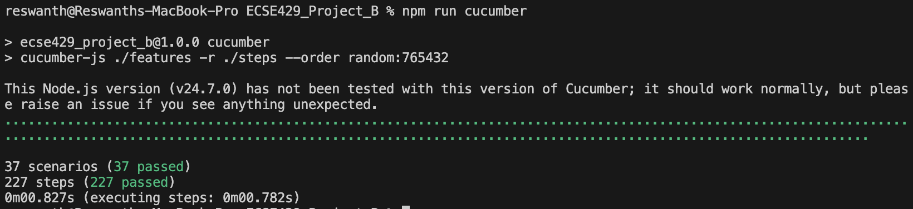
- Discrepancies and bugs recorded:
  - BUG A: Relationship creation with non existent todo id returns 201 for some endpoints. Expected 400 or 404. Captured in Story 1 Error Flow and Story 2 Error Flow. Step definitions log the bug to the console and attach a note rather than failing the entire suite.

Overall Reflections
Overall, the Part B testing phase confirmed the reliability of the TodoManager API and demonstrated complete coverage across our user stories. Future work would include adding concurrent test execution and more complex edge cases to stress-test relationships.
This project as a whole provided hands-on experience with behavior-driven development (BDD) using Cucumber and REST API validation. It strengthened our understanding of automated testing workflows, collaboration through GitHub, and the importance of designing modular and reusable step definitions. Working as a team allowed us to simulate a real QA process — from writing user stories and feature files to debugging API inconsistencies and verifying test independence. The skills and structure established in Part B can serve as a foundation for larger-scale system testing and continuous integration pipelines in future software projects.

